**Arkhadian Project**

Whitepaper 0.13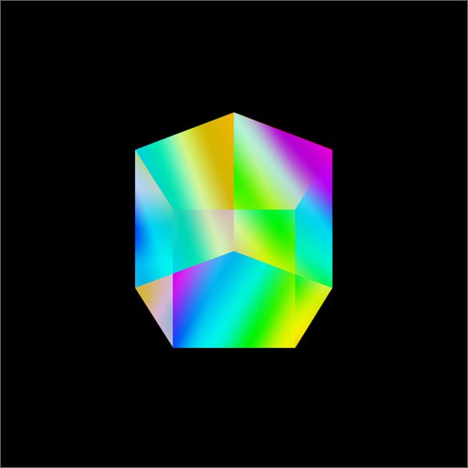

March 2023

Twitter: https://twitter.com/ArkhadianSas

March, 2023

The Arkhadian team

**Abstract**

This paper presents the concepts and theories that underlie the development of the Arkhadian Project, and describes different elements of its implementation and operation.

Decentralized internet protocols, combined with open-source ecosystem and public cryptocurrencies, have the potential to improve socio-economic infrastructure. However, current blockchains like Bitcoin, Zerocash, and Ethereum suffer from energy inefficiency, poor performance, and immature governance mechanisms. Proposed solutions like Segregated-Witness and BitcoinNG are limited by physical capacity, while the Lightning Network may not be suitable for generalized scaling needs. Merged mining allows the work done to secure a parent chain to be reused on a child chain, but it still requires sequential transaction validation and is vulnerable to attack if the majority of hashing power on the parent is not merge-mining the child.

To address these issues, Cosmos, a network of independent blockchains called zones powered by Tendermint Core, a high-performance, consistent, secure PBFT-like consensus engine. Tendermint Core’s BFT consensus algorithm is suitable for scaling public proof-of-stake blockchains. Cosmos allows multiple parallel blockchains to interoperate while retaining their security properties and strict fork-accountability guarantees.

The article suggests the creation of Arkhadian, an innovative structure that utilizes the Cosmos blockchain and surpasses current standards by incorporating advancements in web3 technology.

**Introduction**

Arkhadian is a blockchain platform that aims to provide a decentralized, interoperable blockchain solution based on the Cosmos SDK. The primary objective of Arkhadian is to create a blockchain network that can operate smoothly and seamlessly even if one node is down. The platform is designed to enable people to send ARKH, the native cryptocurrency of the Arkhadian network, around the world with low gas fees and in a matter of minutes.

The Arkhadian platform is built on top of the Cosmos SDK, which is a modular blockchain development framework that enables developers to build custom blockchain applications. The Cosmos SDK is designed to be highly modular, allowing developers to plug and play various modules, such as consensus algorithms and storage solutions, to create a custom blockchain network.

One of the key features of the Arkhadian platform is its ability to remain operational even if one node goes down. This is achieved through the use of a Byzantine Fault Tolerant (BFT) consensus algorithm, which ensures that the network can continue to operate even if a node becomes unavailable or compromised. This makes the Arkhadian network highly resilient and reliable, ensuring that users can continue to transact on the network with minimal disruption.

Another important feature of the Arkhadian platform is its low gas fees. Gas fees are a crucial aspect of any blockchain network as they determine the cost of performing transactions on the network. High gas fees can make it prohibitively expensive for users to transact on the network, limiting the adoption of the platform. Arkhadian aims to solve this problem by offering low gas fees, making it an attractive option for users who want to transact on the network without incurring significant costs.

In addition to low gas fees and BFT consensus, the Arkhadian platform also offers fast transaction times. The platform is designed to enable users to send ARKH around the world in a matter of minutes, making it ideal for applications that require fast transaction speeds, such as micropayments and remittances.

Overall, the Arkhadian platform is a promising blockchain solution that offers a range of features designed to make it an attractive option for users looking to transact on a decentralized, interoperable blockchain network. With its low gas fees, fast transaction times, and BFT consensus algorithm, Arkhadian is well-positioned to become a leading blockchain platform in the years to come.

**Content**

A. Abstract..........................................................................................................2

B. Introduction....................................................................................................3

C. Content...........................................................................................................4

1. Cosmos ecosystem.......................................................................................5

2. Blockchain technology...................................................................................6

3. The Arkhadian Project Overview...................................................................14

- Protocol

4. Use Cases.......................................................................................................16

- Decentralized Finance (DeFi)

- DAO creation

- Payments and Transactions

- Staking

5. Validators........................................................................................................19

- Becoming a validator

6. Assumable Theoretical Attacks....................................................................21

7. Arkhadian explorer.........................................................................................22

8. Tokenomics....................................................................................................23

9. Roadmap........................................................................................................25

10. Disclaimer.....................................................................................................26

11. Social media platforms...............................................................................27

**Cosmos ecosystem**

Cosmos is a network of independent parallel blockchains that are each powered by classical BFT consensus algorithms like Tendermint 1.

The first blockchain in this network is the Cosmos Hub. The Cosmos Hub connects to many other blockchains (or zones) via a novel inter-blockchain communication protocol. The Cosmos Hub tracks numerous token types and keeps record of the total number of tokens in each connected zone. Tokens can be transferred from one zone to another securely and quickly without the need for a liquid exchange between zones, because all inter-zone coin transfers go through the Cosmos Hub.

This architecture solves many problems that the blockchain space faces today, such as application interoperability, scalability, and seamless upgradability. For example, zones derived from Bitcoind, Go-Ethereum, CryptoNote, ZCash, or any blockchain system can be plugged into the Cosmos Hub. These zones allow Cosmos to scale infinitely to meet global transaction demand. Zones are also a great fit for a distributed exchange.

Cosmos is not just a single distributed ledger, and the Cosmos Hub isn’t a walled garden or the center of its universe. We are designing a protocol for an open network of distributed ledgers that can serve as a new foundation for future ynancial systems,based on principles of cryptography, sound economics, consensus theory, transparency, and accountability

**Blockchain Technology**

Blockchain technology is a complex base layer allowing open-source protocols and decentralized applications to be built on top of it. The Arkhadian project in the Cosmos ecosystem was built with the Cosmos SDK.

This section will walk you through the Secret technology stack to get a better understanding of what’s under the hood of the privacy hub for Web3. This "Blockchain technology" section starts with a quick grasp of the different blockchain layers are and an explanation of the Cosmos stack

1. Cosmos introduction

2. Cosmos sdk

3. Inter-blokchain communication (IBC)

4. CosmWasm smart contract

**Cosmos Basics**

A simple way to describe a blockchain is that it’s a distributed ledger on a peer-to-peer (P2P) network where each node of that network contains a copy of the blockchain state. The state of the blockchain is updated by an application and broadcast to each node, agreeing on this new state through consensus.

Cosmos is an ecosystem of independent, interconnected and application specific blockchains commonly referred to as the internet of blockchains. By having all these application specific interconnected blockchains, the ecosystem can easily scale horizontally which avoids most of the bottlenecks and scalability issues we know today on other heterogenous blockchains.

Conceptual layers of a Blockchain are:

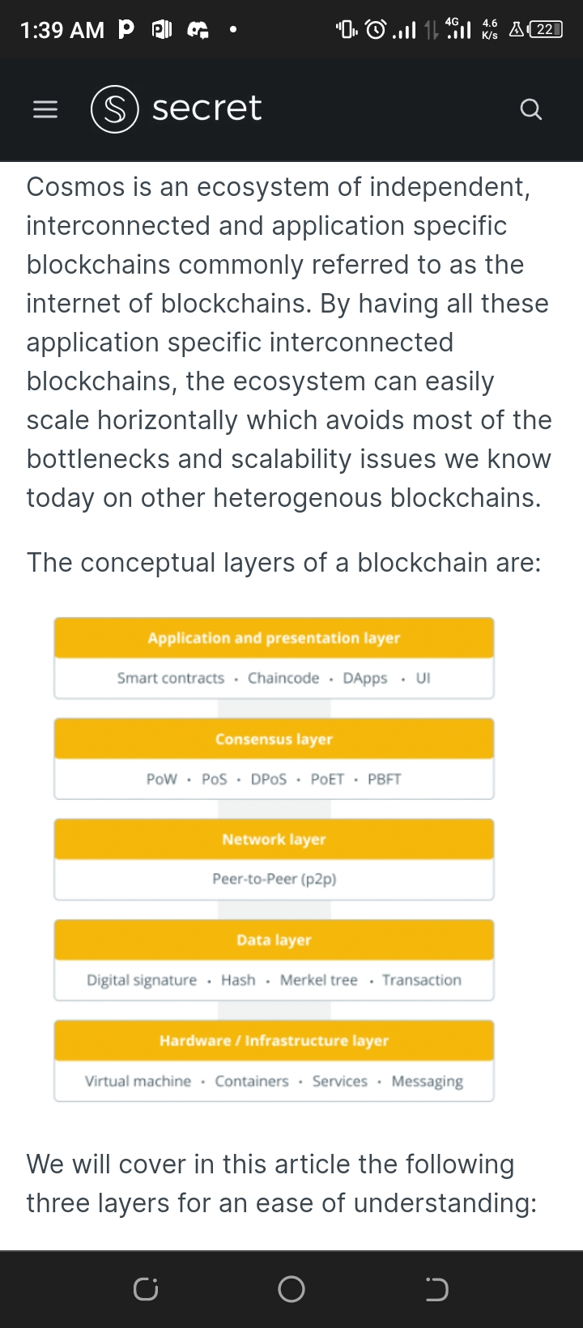

**Tendermint and Cosmos SDK**

To reach adoption and grow the internet of blockchain, developers should focus on their application specific development. They should not spend time on building from scratch the consensus and networking layers. That’s what Tendermint core is taking care of by providing Networking and Consensus layers saving a lot of time and headaches for the developers.

The following figure shows the Networking and Consensus layers as “Tendermint Core” and Cosmos SDK as the “Application layer”:

On top of Tendermint Core, Cosmos introduced the Cosmos SDK, an open-source framework for building application specific blockchains with composable modules (plugins) to help developers build their blockchain faster and easier. Developers could build their application directly on Tendermint core using ABCI to interact with Tendermint but Cosmos SDK allows a faster and battle tested path to bootstrap an application.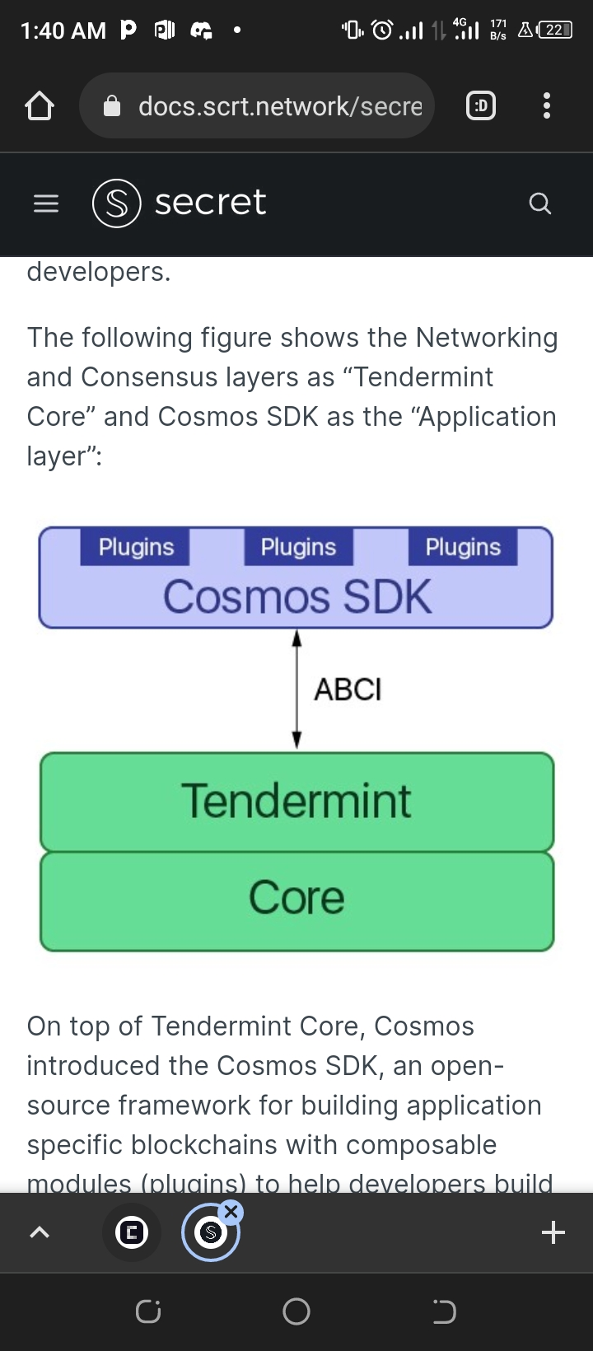

Interoperability at the Base Layer

In order to scale horizontally and fulfill the vision of an internet of interoperable blockchains, blockchains can support the Inter-Blockchain Communication Protocol (IBC), which enables value transfers, token transfers, and other communication between chains, all without the need to involve exchanges or make compromises regarding the chains' sovereignties. Following figures show blockchains interconnected with IBC (IBC Networks)

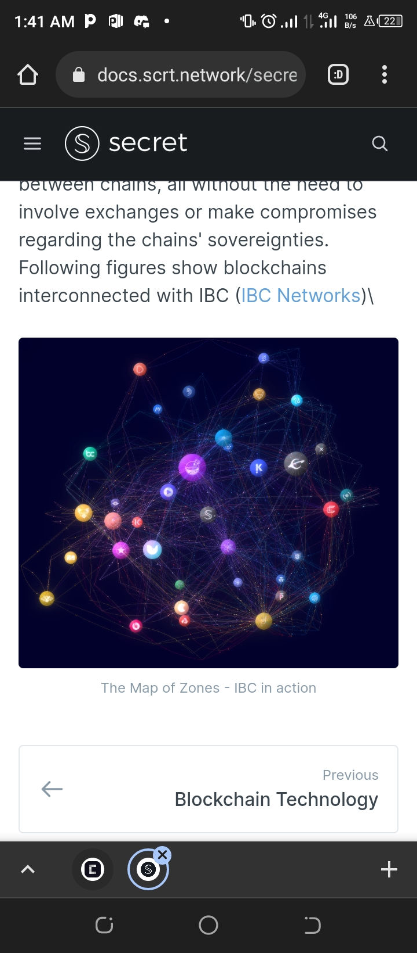

**Tendermint**

In distributed systems, replication of information on all machines is fundamental. In our case, Tendermint is responsible for replicating securely and consistently the state-machine amongst the nodes of the system.

It is composed of a Byzantine-Fault-Tolerance (BFT) Proof-of-Stake (PoS) consensus algorithm and a peer-to-peer networking protocol. It communicates to the application layer through the ABCI protocol.

Tendermint allows developers to focus on the application level and not take care of peer discovery, block propagation, consensus, etc …

Byzantine-Fault-Tolerance (BFT)

In short, BFT represents the ability of a system to continue operating even if some of its nodes fail or act maliciously. In the Tendermint case, it can only tolerate up to a 1/3 of failures, meaning that the blockchain will halt momentarily until a 2/3 of the validator set comes to consensus.

Unlike Nakamoto consensus where it’s subject to 51% attack (meaning that 51% of the actors acting maliciously could attack and alter the blockchain), Tendermint is more resistant as it is subject to a 66% attack.

**Consensus**

Tendermint is a consensus module that combines proof-of-stake and Byzantine Fault Tolerance (BFT) to ensure that all nodes in the network maintain the same blockchain with the same list of blocks containing past transactions. Transactions are received by the node and go into a local cache mempool before being checked for validity by the application through the "CheckTx" message. If the transaction is valid, it is added to the mempool and broadcasted to peer nodes. A new consensus round is initiated with a proposer node that selects transactions from the mempool to include in a new block. The proposed block is broadcasted to all nodes, and a pre-vote phase begins where nodes verify the block's validity and the proposer's validity. If over two-thirds of nodes pre-vote for the block, the pre-commit phase begins, where nodes sign a pre-commit message to ensure that enough validators witnessed the result of the pre-vote stage. Once over two-thirds of nodes sign the pre-commit message, the block is committed, broadcasted to all nodes, and the transactions in the block are executed to update the application's state.

Tendermint's consensus ensures instant finality once a block is committed, meaning there is no way to revert it. Decentralization is measured by the voting power distribution amongst validators, where users can delegate their voting power to a validator based on their reputation, stability, security, and infrastructure. The amount of native chain token owned and delegated to a validator represents its voting power, giving them the opportunity to be a new block proposer more often. The Application Blockchain Interface (ABCI) layer is the communication protocol for Tendermint to make requests to the application, such as checking transactions' validity, delivering transactions to the application, and querying the application for account balance. Overall, Tendermint's consensus process ensures that all nodes maintain the same blockchain and that any node can propose a block through proposer rotation.

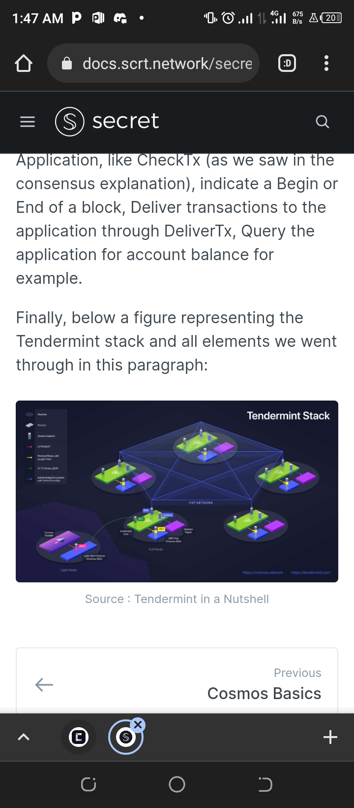

The main difference when it comes to Cosmos compared to virtual-machine blockchain, is the application-specific blockchain concept. Developers can build from scratch their application specific blockchain on top of Tendermint through ABCI protocol. Cosmos SDK is the framework offering a bank of independent modules for implementing the application state machine, ABCI, service routers to route messages between modules, and a flavor of features like governance, staking, slashing, etc …

Cosmos Virtual Machine

Below a figure showing the architecture differences between a VM blockchain and Cosmos:



Cosmos is a decentralized network that aims to create an ecosystem of interconnected application-specific blockchains. It provides an efficient and proven technology that allows developers to create their own blockchains, tailored to their specific needs. The Cosmos SDK provides an easy and fast way to bootstrap application-specific blockchains, without compromising on security or sovereignty. This is achieved by allowing developers to tweak the framework, consensus engine, or any modules to match their application/network requirements.

One of the main advantages of Cosmos SDK is that it does not rely on a virtual machine (VM) to execute smart contracts. This eliminates the need for a specific programming language accepted by the VM, which can be a limitation for some developers. The VM also has a limited set of functions, and lacks flexibility. By not relying on a VM, Cosmos SDK allows developers to use their own cryptography or audited libraries, giving them more control over the security of their blockchain.

Furthermore, Cosmos SDK provides a performance boost as it eliminates the competition for block resources between applications. As a result, performance is enhanced and is only limited by the state machine itself. This is a significant advantage over other blockchains that rely on a VM, as the performance is often restricted by the VM computation.

Cosmos SDK provides developers with access to an extensive module library, allowing them to build more complex applications with ease. Developers can use these modules to build applications such as identity systems, payment systems, and prediction markets. These modules can be used to customize the blockchain, making it more efficient, secure, and tailored to the specific application.

**Interconn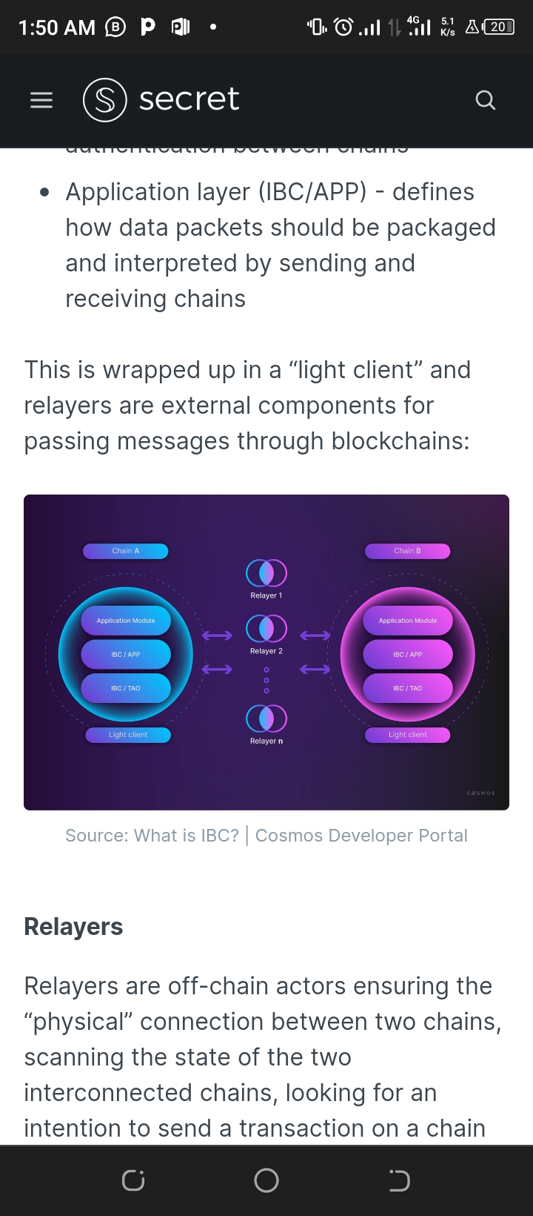ected Blockchains:**

The Inter-Blockchain Communication Protocol (IBC) is a core component of the Cosmos ecosystem. It allows different blockchains to communicate with each other in a standardized and secure way. IBC is responsible for relaying data packets between arbitrary state machines (i.e application blockchains), and provides a generic and standard protocol implementation for transferring value between chains.

IBC is not limited to Cosmos blockchains and can be used by other blockchains with different consensus mechanisms. For example, Ethereum could use a peg zone to communicate with the Cosmos ecosystem. This interoperability allows for more efficient value transfer, enabling decentralized exchanges and other decentralized applications to be built on top of the Cosmos ecosystem.

The IBC stack is composed of two layers: the transport layer (IBC/TAO) and the application layer (IBC/APP). The transport layer provides the infrastructure for establishing secure connections and data packet authentication between chains. The application layer defines how data packets should be packaged and interpreted by sending and receiving chains. This is facilitated by external relayers that pass messages through blockchains.

The IBC protocol provides a common protocol for blockchains to communicate in a standardized and trustless way. This allows for the creation of an ecosystem of interconnected blockchains that can exchange value and information seamlessly. This interoperability is critical to the success of decentralized finance (DeFi), enabling a seamless flow of assets between different blockchains.

**Relayers and IBC**

Relayers are off-chain entities that facilitate communication between interconnected blockchains. They scan the state of the interconnected chains to detect transactions that need to be sent from one chain to another. For example, if someone wants to transfer fungible tokens from Chain A to Chain B, relayers prove that the tokens are locked in Chain A and provide a voucher representing them on Chain B. They use the light client of each blockchain to verify incoming messages on Chain A and then submit them (along with the proof of commitment) on Chain B.

In contrast to other bridge solutions, IBC does not require third-party involvement or multisig for transferring value/messages between blockchains. IBC relies on "native security," which means that as long as two connected blockchains are trusted, any tokens transferred between them through IBC are also trusted. The security of IBC is based on trust in the connected blockchains and fault isolation mechanisms that limit the damage caused by any malicious activity. Light clients validate proofs to ensure that IBC is Byzantine resistant. IBC also enables transfer of non-fungible tokens, multi-chain smart contracts, and interchain accounts. For example, Secret Network can serve as a privacy hub for the Interchain, allowing other Cosmos chains to store and manipulate private data (even private keys) on Secret Network from their own chains. The figure below illustrates how an IBC packet travels between blockchains.

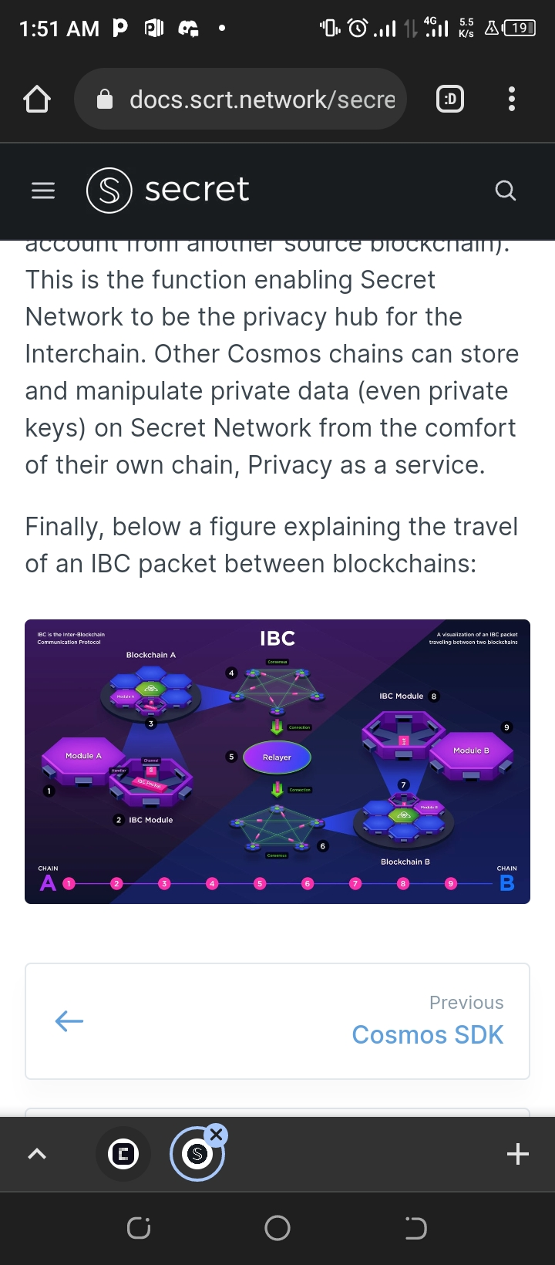

**CosmWasm**

Introduction to CosmWasm

CosmWasm is a framework that enables developers to create secure smart contracts in Rust for use in any blockchain built with the Cosmos SDK. It provides a way to implement new features with modular and reusable code, without needing to understand the underlying details of the blockchain. The smart contracts are executed safely within a virtual machine (VM) using WebAssembly (WASM) as an intermediary language compiler for the VM.

CosmWasm SmartContracts

In the world of blockchain, smart contracts are a way for parties to interact with each other through a set of rules written in code and stored on the blockchain. Many attempts have been made to make smart contracts safer, but they have been either too complicated or ineffective. However, CosmWasm is a solution that is both easy to use and effective. It does this by wrapping Rust binaries as secure smart contracts that are verified by the compiler and contain all their dependencies linked statically. This ensures that attackers cannot modify the contract after it has been deployed on the blockchain.

CosmWasm development flow

Using CosmWasm doesn't require knowledge of Rust programming language. If you're a developer and want to write contracts using CosmWasm, you can use any programming language that generates a WASM binary with no external dependencies and defines the correct entry points. This means that you have the freedom to use any programming language you prefer, such as Go or Python, and still be able to deploy it with CosmWasm.

**The Arkhadian Project Overview**

ARKH is a blockchain built using Cosmos SDK and Tendermint and created with Starport. The purpose of $ARKH token is enormous, made for DAO creation, transactional purposes and spendings, built on the cosmos Blockchain, the $ARKH token relies on CosmWasm, a framework that helps developers to create secure smart contract.

**Encryption at deployment of contract**

When a contract is executed on chain the state of the contracts needs to be encrypted so that observers can not see the computation that is initialized. The contract should be able to call certain functions inside the enclave and store the contract state on-chain.

A contract can call 3 different functions: write_db(field_name, value), read_db(field_name), and remove_db(field_name) . It is important that the field_name remains constant between contract calls.

**Transaction Encryption**

Transaction encryption unlike contract state encryption has two parties who need data access. The scheme therefore makes use of the DH-key exchange as described in the previous section to generate a shared encryption key. This symmetric tx_encryption_key is unique for every transaction and can be used by both the network and the user to verify the completed transactions.

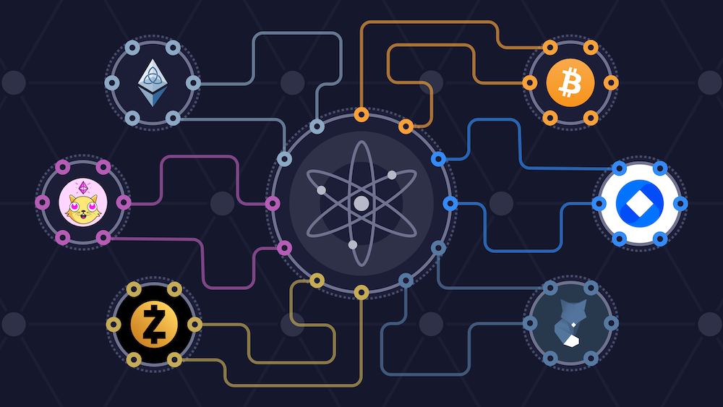

**Protocol**

func WasmKeeper(t testing.TB) (*keeper.Keeper, sdk.Context) {

storeKey := sdk.NewKVStoreKey(types.StoreKey)

memStoreKey := stor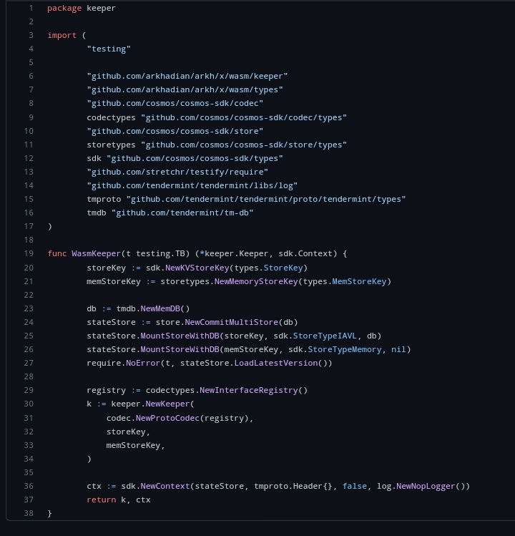etypes.NewMemoryStoreKey(types.MemStoreKey)

**Use Cases**

Due to the transparent nature of public blockchains, there has never been a protocol that allows for complete or central control over data transparency.

$ARKH token can be used in:

1. Decentralized finance (DeFi)

2. DAO creation

3. Payment and transactions

4. Staking

**Decentralized Finance (DeFi)**

Imagine sending money or making a payment without the assistance of a bank, brokerage, or any other official intermediary, then you’ve grasped the essence of decentralized finance.

Decentralized finance—or DeFi for short—is an emerging digital ecosystem that allows people to send, purchase, and exchange financial assets without relying on banks, brokerages, or exchanges. DeFi sidesteps the traditional pathways to making financial transactions.

DeFi’s emergence may be quite significant. It doesn’t merely point to a new form of financial tech on the horizon; it promises a new financial horizon altogether.

The $ARKH token offers you this opportunity to interact on the Blockchain and make transactions without any bank or brokerage involved.

The $ARKH token built on the cosmos ecosystem, built with cosmos sdk is a financial system on a blockchain-based network, and eliminating the go-betweens, transactions can be more direct; service fees can be largely eliminated; and asset transfers and exchanges can be made virtually tamper proof.

Blockchains are digital ledgers that are shared and updated by all participating computers (aka nodes). All transactions that go into a blockchain are verified by select nodes participating in the network. All blocks are encrypted, and once they’re closed, the contents of the block are permanently sealed and cannot be changed. Any attempt at altering the contents of a block will alert all computers on the network (which can number in the high thousands). This is what makes a blockchain virtually impenetrable and safe.

**DAO creation**

When we talk about organizational structures, we usually think about the centralized cluster where instructions flow in a hierarchical chain. This system surely ensures a sense of discipline within the organization. Though, it knocks out the freedom of expression, especially at the lower levels. So, when DAOs came into the picture, business magnates started exploring their potential as a resource for management and control.

In simple words, a DAO is an independent organization managed by the communities. The underlying laws are established via smart contracts that decide the selected course of action to be adopted in the future. The members might at any time openly evaluate DAO’s digital code, cast votes, and give suggestions.

The Arkhadian Project makes room for DAO creation, the entire infrastructure of a DAO blockchain platform is solely managed by its members, who collaborate on key project decisions, including technological improvements and treasury allocations. In our project, every member has a say to suggest what is right and what should be done. The protocol’s future improvements are proposed by community leaders, who then get together to vote on each one individually. The established requirements decided upon in the smart contracts help to reach a predetermined point of agreement with complete transparency.

Those who support Decentralized Autonomous Organizations unanimously vouch for its potential to fundamentally alter the way firms operate. These entities are revolutionizing the working and decision-making paradigms of the global business space. Currently, several DAO projects are available in the market, accomplishing some impressive feats. The concept is new and challenging. At the center of decision making, $ARKH is solely focused on ensuring that the will of holders of it's token stands and this therefore makes every hodler a stakeholder in the project.

**Protocol DAOs**

Protocol DAO is the most prevalent form of decentralized autonomous organization. A protocol DAO, as the name implies, focuses on governance via decentralized protocols. To deliver DeFi services, several DAOs use smart contract technologies. ARKH token is not left behind on this, as we have chosen the cosmos ecosystem for this purpose and to enlarge our horizon, more would be done to sustain this course!

**Payments And Transactions**

The core issue with public blockchains, when it comes to cryptocurrency payment is the lack of transactional privacy. This creates a huge barrier to adoption. You should be able to spend your cryptocurrencies and stablecoins without revealing wallet balances and worst of all, your entire transaction history.

Does your favorite coffee shop have access to your bank account balance when you’re swiping your credit card? We should certainly expect that level of privacy as the minimum standard in this new financial wave of cryptocurrency.

**Privacy In Payments**

A straightforward use case would be a payment platform leveraging Arkhadian privacy to pay with cryptocurrency and preserving data, and account balance for both the consumer and the business owner without trusting a centralized third party.

**Staking**

Staking is the process of locking up a digital asset (ARKH in the case of the Cosmos Hub) to provide economic security for a public blockchain. When the staking transaction is complete, rewards will start to be generated immediately. At any time, stakers can send a transaction to claim their accumulated rewards, using a wallet. Staking rewards are generated and distributed to staked $ARKH holders. These holders receive earnings in percentage based on the validator used. $ARKH currently has about 84 active validators, this information can be found on the $ARKH explorer.

**Validators**

Nodes with a non-negative amount of voting power that secure the network by cryptographically signing blocks are called validators. Block proposals with BFT consensus are done through a series of votes by validators using broadcasted cryptographic signatures.

Validators earn rewards from transaction fees and block rewards. The more ARKH bonded to any given validator, the greater the likelihood said node will be selected for block proposal. Individuals may delegate to validators and earn rewards for bonding a certain amount of ARKH out of active circulatin.

The $ARKH token has close to about a hundred validators with about eighty-five(85) active validators. As of the time of writing this, Kynraze leads as the number one active validator with about 11,900 bonded $ARKH tokens and at a 19% annual profit.

https://arkh-rpc.kynraze.com

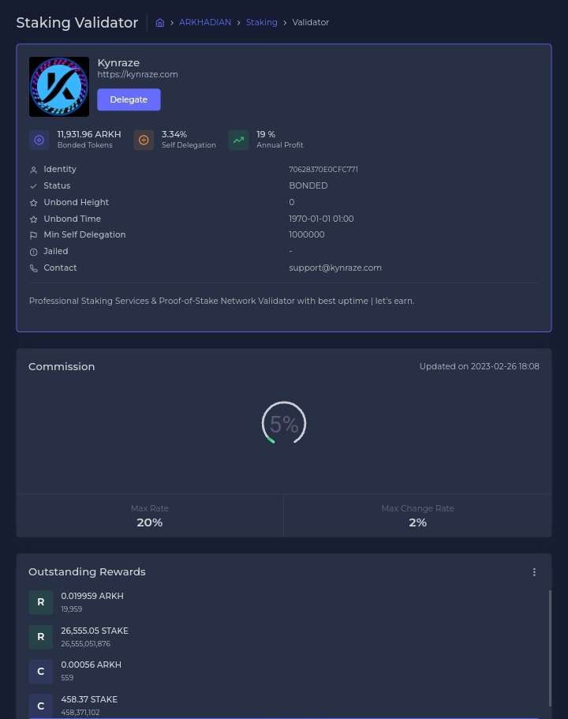

**Becoming a validator**

Arkhadian holders who are not already validators can become validators by signing and submitting a BondTx transaction and making a request to become a validator on our discord platform. The amount of atoms provided as collateral must be nonzero. Anyone can become a validator at any time, except when the size of the current validator set is greater than the maximum number of validators allowed. In that case, the transaction is only valid if the amount of ARKH is greater than the amount of effective ARKH held by the smallest validator, where effective ARKH include delegated ARKH. When a new validator replaces an existing validator in such a way, the existing validator becomes inactive and all the $ARKH tokens and delegated $ARKH tokens enter the unbonding state. Validators are making snapshot every 4hours.

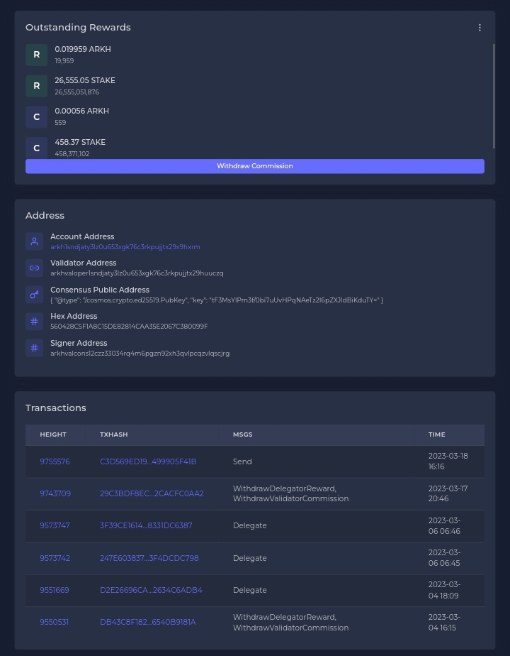

Typical image of how the validator explorer should look like.

**Assumable Theoretical Attacks**

Evaluating potential attack is integral to the formation of a protocol that is designed to be the fundamental privacy layer for all blockchain protocols. It is important to note that the majority of all assumable theoretical attacks, similar to other protocols, decentralization helps secure the network’s consensus layer against Byzantine attacks. As a starting point examining non-consensus layer attacks.

Probable attacks are:

● Transaction replay attack

● Partial storage rollback during contract runtime

● Transaction output data leakage

● Vulnerability enabling a Byzantine node to acquire the consensus seed from the enclave

We believe that the $ARKH token is not prone to constant attacks. A bounty was made which led to a PR that got $ARKH recognized and listed. Arkhadian project developer gave out 500 $ARKH to the winner of the bounty.

**Arkhadian explorer**

**Total supply:** 800M **Height:** 9774417  **Inflation:** 20%

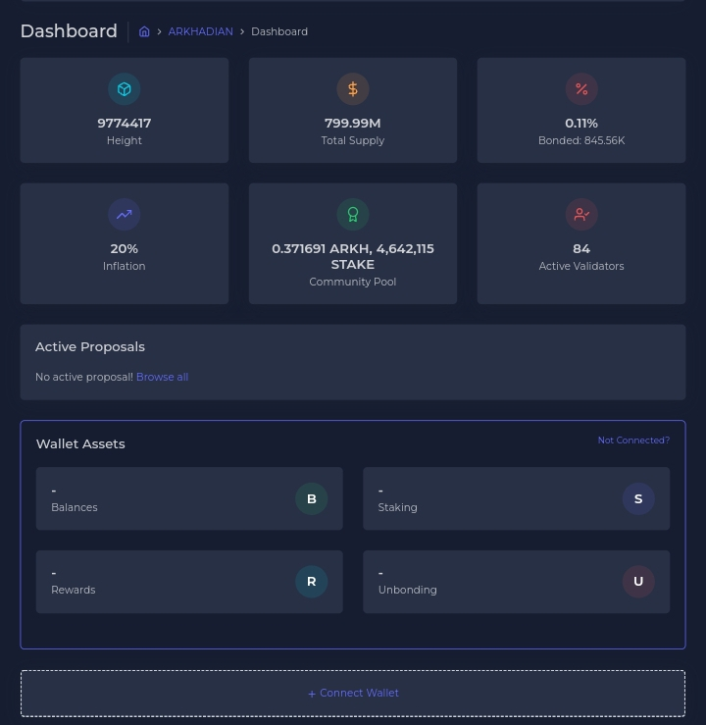**Bonded:** 0.11% **Community pool:** 0.371691 Arkh, 4,642,115 Stake

**Active Validators:** 84

Proposed initial ending supply of the $ARKH is: 35 000 000arkh

**Important sites and links to check the Arkhadian Blockchain explorer.**

https://grpc.arkh.nodestake.top

wss://rpc.arkh.nodestake.top/websocket

https://arkh-rpc.kynraze.com

https://explorer.enodex.lol/arkhadian/staking

**Tokenomics**

* Presale is live and ARKH is sold on presale at $0.21
* Only less than 10k are in circulation
* Proposed market cap at listing would be 168M if listed at 0.21$
* The decrease process is through burning
* Staking APR quite low on ARKH but high on $stake

The tokenomic is simple, people have two reward $stake (inflationnary) and $arkh (deflationnary). total supply of $ARKH is 800M will decrease to 35M. We will be able to swap stake for arkh with a ratio of 1arkh:100stake.

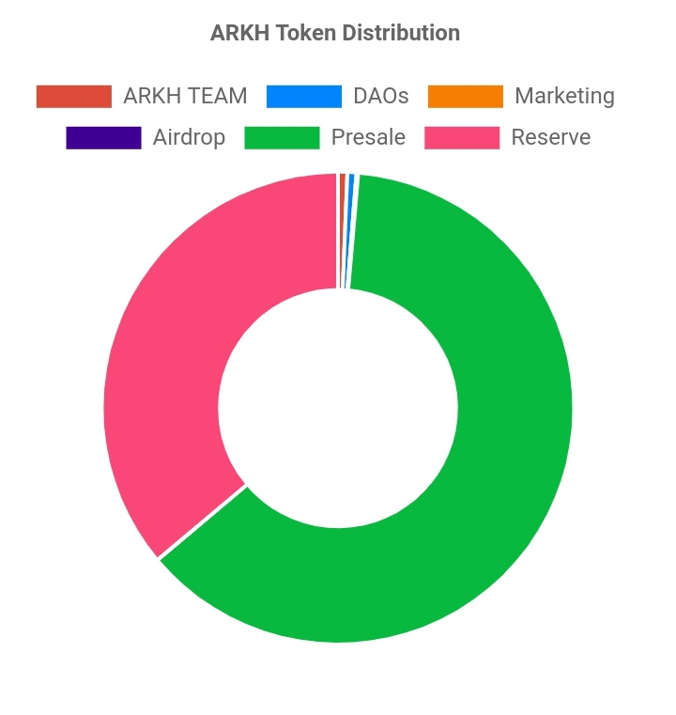

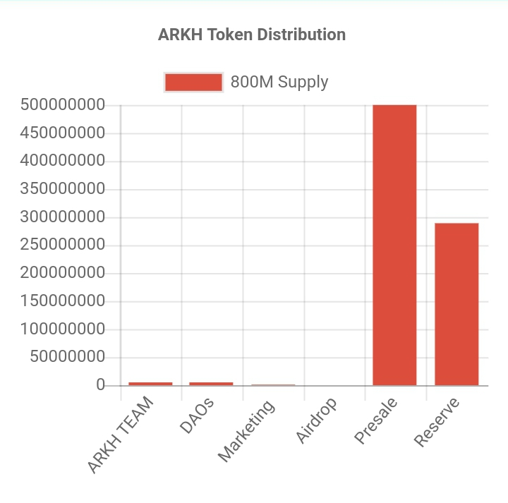

**Roadmap**

**Phase 1:** Blockchain creation (done)

Description: creating ARKH chain with cosmos sdk and kepirwallet (Checked✅)

**Phase 2:** long term Ico

Description: When arkh are available, bidding room can be opened

**Phase 3:** Mintscan

Description: Creating a mintscan for ARKH chain

**Phase 4:** Cosmwasm

Description: Adding the possibility for users to create smart contracts and release it on chain

**Phase 5:** app.arkhadian.com

Kuji like order book, but with better UI

**Phase 6:** app.arkhadian.com online trading

Description: trade fiat or crypto on app.arkhadian.com

**Phase 7:** Rewarding shareholders with the capital created. (Each validator or delegator) is producing shares of the blockchain. Smart contract will send a percentage of the capital available to the shareholders by period of time.

**Secret phase 8**

**Secret phase 9**

**Secret phase 10**

**Disclaimer**

The details of this file is subjected to subsequent adjustment and review as we improve on our technology and infrastructure.

**Social media platforms**



https://twitter.com/ArkhadianSas

https://discord.gg/7WrbuJNe

Our Telegram group is a work in progress